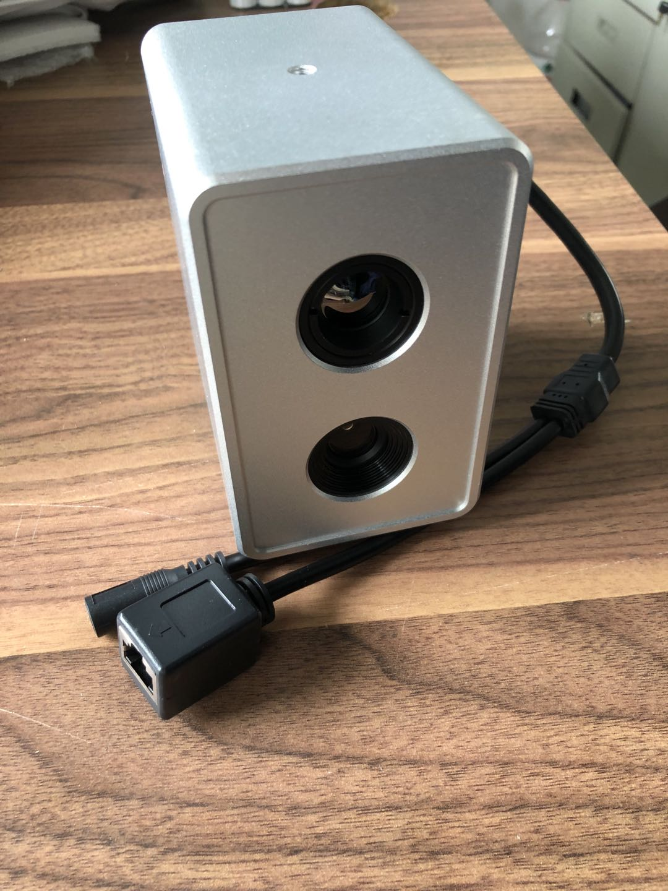
Human body temperature camera

key features：
Support real-time temperature correction for black body to achieve accurate temperature measurement, temperature measurement accuracy ≤ ± 0.3 ℃ (without black body temperature measurement accuracy ≤ ± 0.5 ℃)
● Use infrared thermal imaging body temperature detection to achieve long-range, non-contact rapid temperature measurement and reduce the risk of infection
● High-sensitivity detector with thermal imaging resolutions of 384x288 and 640x480, supporting contrast adjustment;
● Automatic and rapid temperature measurement and screening for multiple targets at the same time to meet the efficient temperature measurement and screening in dense areas of large areas;
● Supports pre-set temperature alarm thresholds, automatic alarms for abnormal temperature, and automatic capture of fever targets to provide evidence for subsequent evidence collection;
● Support intelligent face capture recognition function, personnel information can be found, reducing misjudgment and more accurate;
● Equipped with a 10,000-level face database as standard, which can be used for face control, can be linked with public security population information management platforms, or quickly connect to third-party platforms, control personnel identity information and activity trajectory, and focus on abnormal personnel
● Supports automatic temperature calibration, reducing manual work and improving efficiency;
● Equipped with temperature measurement client software and visual data platform to manage regional data at a glance, realize record backtracking, data analysis, etc .;
● Quick deployment, support for tripod and easy installation, can be quickly removed afterwards;

Specifications
 | 产品型号 | 备注
Without black body | HRT384 | Temperature measurement accuracy: ≤ ±0.5℃, thermal imaging resolution: 384*288, visible light resolution: 2 million
Without black body | HRT640 | Temperature measurement accuracy: ≤ ±0.5℃, thermal imaging resolution: 640*480, visible light resolution: 2 million
With blackbody | HRT384H | Temperature measurement accuracy: ≤ ±0.5℃, thermal imaging resolution: 384*288, visible light resolution: 2 million
With blackbody | HRT640H | Temperature measurement accuracy: ≤ ±0.5℃, thermal imaging resolution: 640*480, visible light resolution: 2 million
Application:
Rapid temperature screening can be conducted in crowded public places. Once the target of excessive body temperature is detected, it will automatically alarm and take photos, which can be used to screen people with fever in large areas, improve the prevention and control efficiency of the epidemic and greatly reduce the risk of infection. To control and reduce the spread of fever outbreaks such as ebola, SARS, zika, xinguan, etc. Large areas of personnel temperature monitoring in airports, ports, bus stations and other public transport places
Technical specs：
Model | Name
Model | Model | HRT384&640 | HRT384&640H
Thermal camera | Sensor type | ULIS | Ulis
Thermal camera | Resolution | 384*288/640*480 | 384*288/640*480
Thermal camera | Pixel size | 17μm | 17μm
Thermal camera | Work wave | 8-14μm | 8-14μm
Thermal camera | NETD | <50mk@300K,f1.0 | <50mk@300K,f1.0
Thermal camera | Optics | 8mm、13mm、19mm、25mm optional | 8mm、13mm、19mm、25mm optional
Thermal camera | Frequency | 50fps | 50fps
Thermal camera | Image color | White hot/Black hot/sepia/IRON/rainbow | White hot/Black hot/sepia/IRON/rainbow
Temperature | Range | 26℃-46℃ | 26℃-46℃
Temperature | blackbody | No | yes
Temperature | Accuracy | ≤ ± 0.5℃ | ≤ ± 0.3℃
Temperature | Measure distance | 1m to 8m base on the optics | 1m to 8m base on the optics
Temperature | Multi-objective temperature measurement | support | support
Visible camera | Sensor type | CMOS low
Visible camera | Resolution | 200W（1920*1080）、400W(2560×1440)optional
Visible camera | Video coding standard | H.264B、H.264M、H.264H、H.265、MJPEG、SVC
Visible camera | Lens interface | M12
Visible camera | Focus | Optional 3.6mm、6mm、8mm、12mm fixed lens
Face recognition | The intelligence function | Face detection, face tracking, face optimization, face attributes, face recognition, face exposure, face enhancement
Face recognition | Face capture performance | At the same time, the maximum detection of 30 faces, the detection of the minimum pixel and the maximum pixel can be set, the detection area can be set
Face recognition | Face capture performance | Face matting, half matting, full matting; The capture rate is not less than 98%, and the repeat capture rate is less than 5%
Face recognition | Face capture mode | Optimal mode, automatic mode, monitoring mode, snapshot number and time can be set
Face recognition | Face attribute analysis | Age, gender, mask, glasses, expression, etc
Face recognition | Face recognition efficiency | Recognition accuracy ≥99.50%, recognition speed ≤ 0.2s
Face recognition | Face library management | In the tube of the face bank of up to 3 people, the largest face bank of 30,000 people, and the storage of 100,000 comparison records
Face recognition | Black and white list | Support blacklist and whitelist comparison, blacklist layout alarm
Software function | Parameter setting | video adjustment, alarm sensitivity setting, shielding area setting, area of interest, etc
Software function | Temperature alarm | high temperature alarm, automatic alarm map capture
Software function | History data | historical alarm data, historical alarm data processing
Software function | Temperature correction | supports automatic temperature correction of body surface
Interfaces | Comm interface | Two 10/100m adaptive Ethernet ports RJ45
Interfaces | Alarm and voice | Alarm 1 in 1 out, audio 1 in 1 out
Interfaces | Storage | Micro SD/SDHC/SDXC卡(128G)，support offline transmission
Interfaces | Signal interface | 1 RS485 interface
General parameter | Power input | DC12V±20% ，power consumption ≤10W
General parameter | Environment | Work temp：-10~50℃ ＜90%（非冷凝）、storage -20~60℃
General parameter | Protection level | Metal structure, anti - surge, anti - static, anti - lightning design
General parameter | dimension(mm) | 125(L)*70(W)*110(H)
